1. Write a HTML code to draw the following Figure:

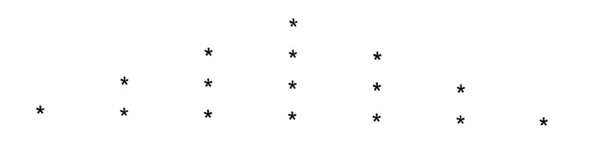

**SOURCE CODE**

**Star.html**

<!DOCTYPE html>

<html lang="en">

<head>

<meta charset="UTF-8">

<meta http-equiv="X-UA-Compatible" content="IE=edge">

<meta name="viewport" content="width=device-width, initial-scale=1.0">

<title>Star Pattern </title>

</head>

<body>

<div style="padding: 20px;">

<div>

<h1>Star Pattern</h1>

<p>&ensp; &ensp; &ensp; &ensp; &ensp; &ensp; *</p>

<p>&ensp; &ensp; &ensp; &ensp; * &ensp; * &ensp; *</p>

<p>&ensp; &ensp; * &ensp; * &ensp; * &ensp; * &ensp; *</p>

<p>&ensp; * &ensp; * &ensp; * &ensp; * &ensp; * &ensp; *</p>

</div>

<hr>

<h4 style="text-align: center;">Name : Vipul Kumar, Roll NO : 61 (2018856)</h4>

</div>

</body>

</html>

**OUTPUT**

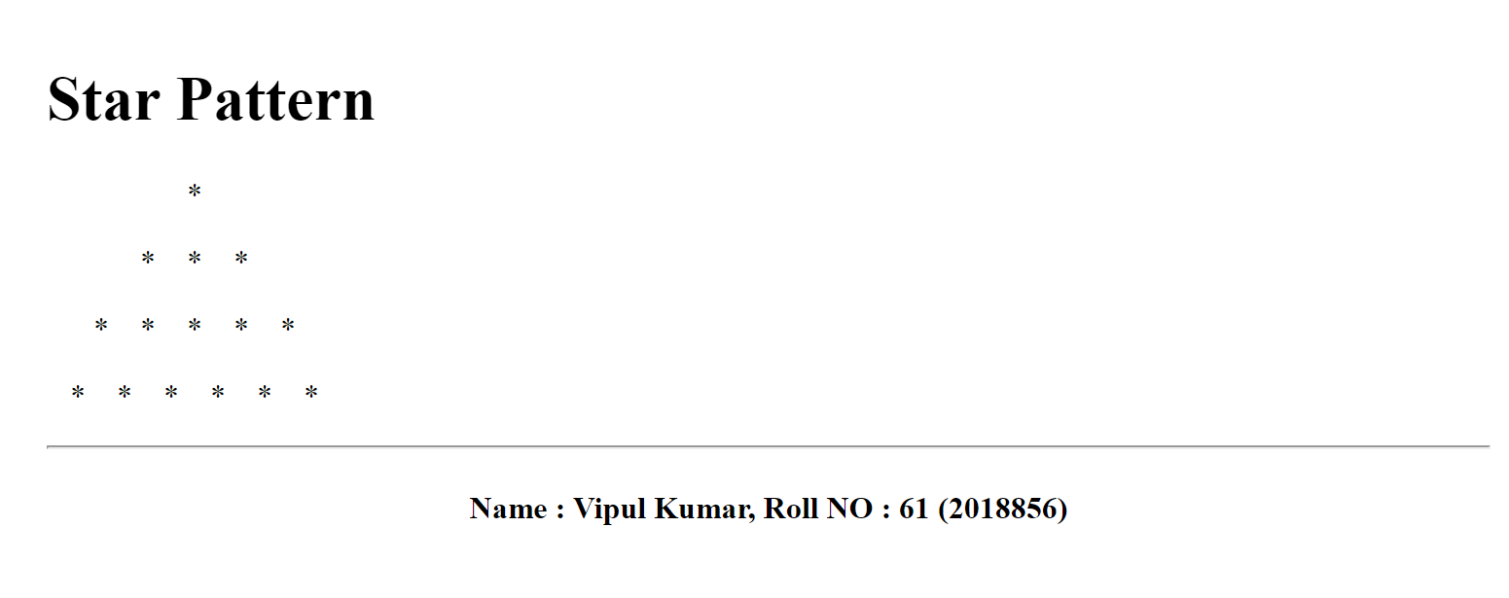

1. Create a web page to print the following table.

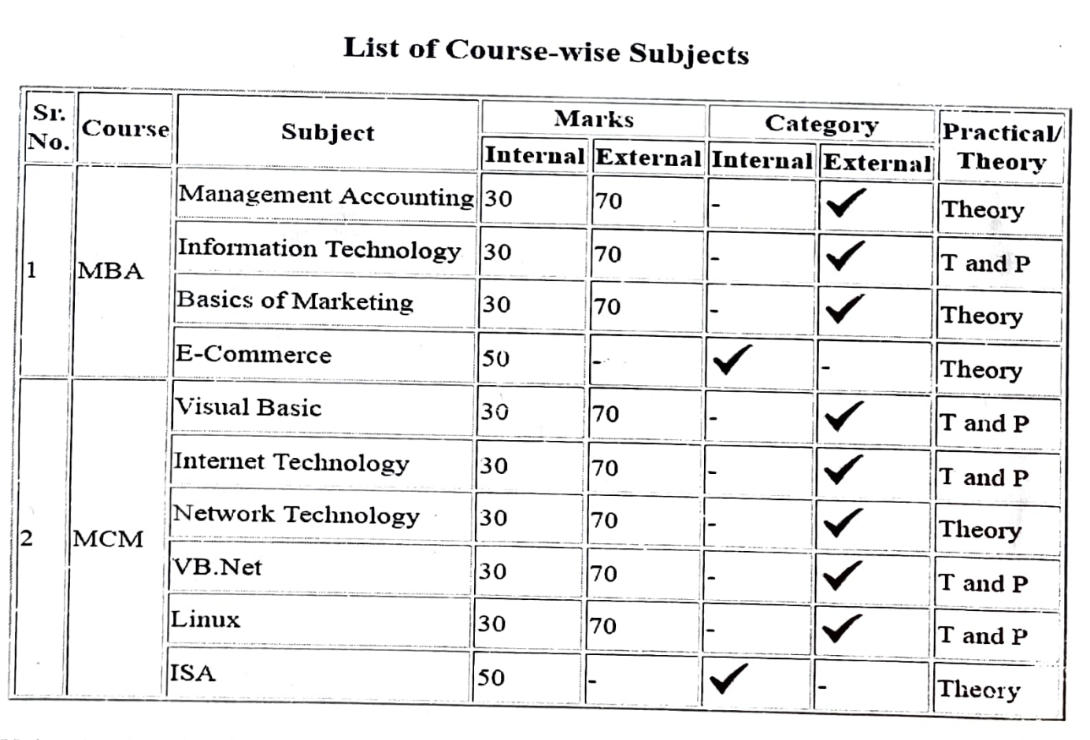

**SOURCE CODE**

**Table.html**

<!DOCTYPE html>

<html lang="en">

<head>

<meta charset="UTF-8">

<meta http-equiv="X-UA-Compatible" content="IE=edge">

<meta name="viewport" content="width=device-width, initial-scale=1.0">

<title>Table In HTML</title>

<style>

caption {

font-size: 20px;

margin: 20px;

}

h4 {

text-align: center;

}

</style>

</head>

<body>

<table border="1" align="center" cellpadding="3">

<caption>List of course wise Subjects.</caption>

<tr>

<th rowspan="2">S.NO.</th>

<th rowspan="2">Course</th>

<!-- <th>S.NO.</th> -->

<th rowspan="2">Subject</th>

<th colspan="2">Marks</th>

<th colspan="2">Category</th>

<th rowspan="2">Pratical/Theroy</th>

</tr>

<tr>

<td>Internal</td>

<td>External</td>

<td>Internal</td>

<td>External</td>

</tr>

<tr>

<td rowspan="5">1</td>

<td rowspan="5">MBA</td>

</tr>

<tr>

<td>Management Accounting</td>

<td>30</td>

<td>70</td>

<td>_</td>

<td>&#x2713</td>

<td>Theory</td>

</tr>

<tr>

<td>Infroamation technology</td>

<td>30</td>

<td>70</td>

<td>_</td>

<td>&#x2713</td>

<td>T and P</td>

</tr>

<tr>

<td>Basic Or</td>

<td>30</td>

<td>70</td>

<td>_</td>

<td>&#x2713</td>

<td>Theory</td>

</tr>

<tr>

<td>E-Commerce</td>

<td>30</td>

<td>_</td>

<td>&#x2713</td>

<td>_</td>

<td>Theory</td>

</tr>

<tr>

<td rowspan="7">2</td>

<td rowspan="7">MCM</td>

</tr>

<tr>

<td>Visual Basic</td>

<td>30</td>

<td>70</td>

<td>_</td>

<td>&#x2713</td>

<td>Theory</td>

</tr>

<tr>

<td>Internet Technology </td>

<td>30</td>

<td>70</td>

<td>_</td>

<td>&#x2713</td>

<td>Theory</td>

</tr>

<tr>

<td>Network Technology </td>

<td>30</td>

<td>70</td>

<td>_</td>

<td>&#x2713</td>

<td>Theory</td>

</tr>

<tr>

<td>VB. Net</td>

<td>30</td>

<td>70</td>

<td>_</td>

<td>&#x2713</td>

<td>T and P</td>

</tr>

<tr>

<td>Linux</td>

<td>30</td>

<td>70</td>

<td>_</td>

<td>&#x2713</td>

<td>T and P</td>

</tr>

<tr>

<td>ISA</td>

<td>50</td>

<td>-</td>

<td>&#x2713</td>

<td>_</td>

<td>Theory</td>

</tr>

</table>

<br>

<hr>

<h4 style="text-align: center;">Name : Vipul Kumar, Roll NO : 61 (2018856)</h4>

</body>

</html>

**OUTPUT**

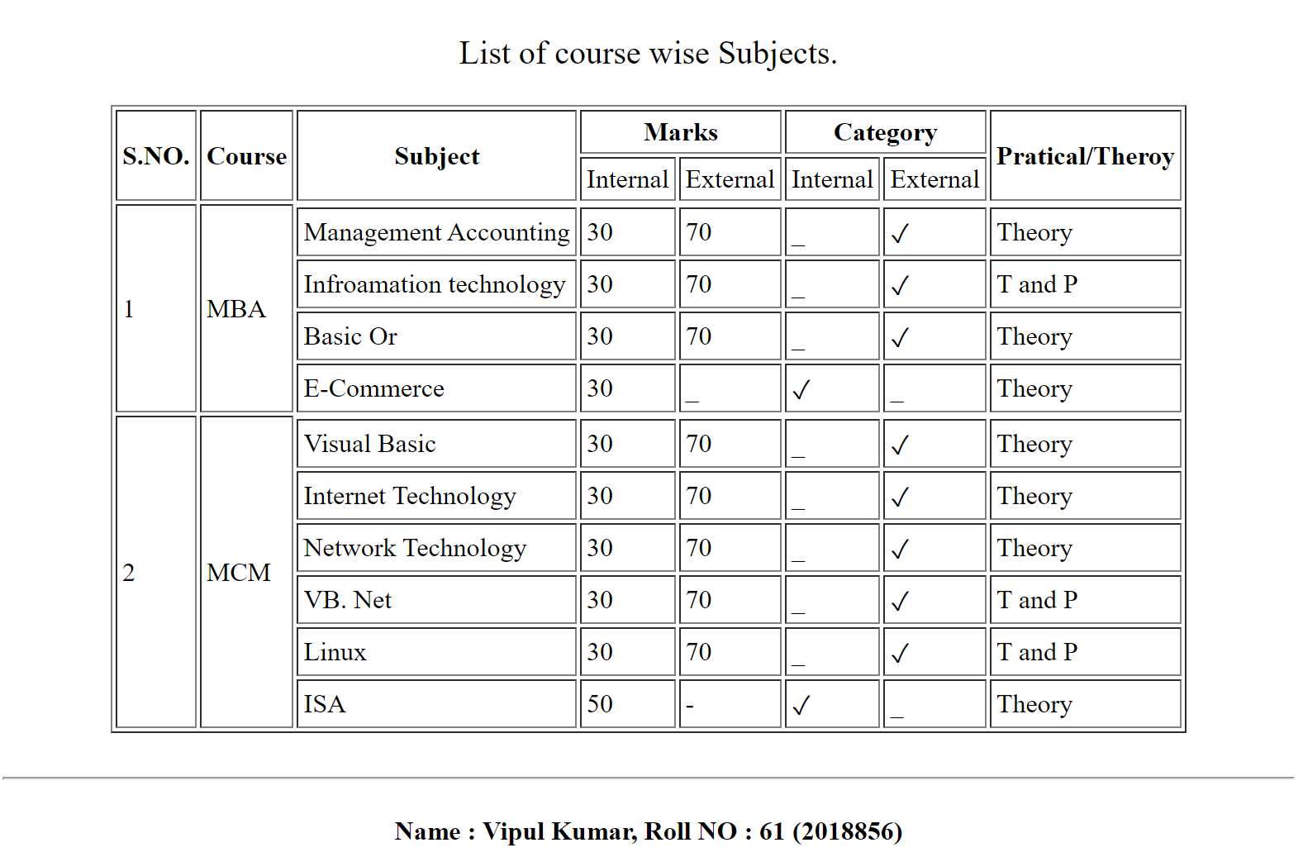

Q3. Using table related tags align the images with hyperlinks.

**SOURCE CODE**

**Index.html**

<!DOCTYPE html>

<html lang="en">

<head>

<meta charset="UTF-8">

<meta http-equiv="X-UA-Compatible" content="IE=edge">

<meta name="viewport" content="width=device-width, initial-scale=1.0">

<title>Table With Mobile Connections</title>

<style>

.text {

font-size: 20px;

font-weight: 600;

}

table td {

border: 1px solid black;

border-collapse: collapse;

}

caption {

margin: 20px;

font-size: 20px;

}

h4 {

text-align: center;

}

</style>

</head>

<body>

<table border="0" align="center">

<b>

<caption><b>Table With Mobile Connections</b></caption>

</b>

<tr>

<td>

<img height="100" width="100"

src="https://telecomtalk.info/wp-content/uploads/2022/10/vodafone-confirms-talks-with-hutchisons-three-over-1.jpeg"

alt="VI">

</td>

<td>

<img height="100" width="100"

src="https://upload.wikimedia.org/wikipedia/commons/thumb/5/50/Reliance_Jio_Logo_%28October_2015%29.svg/800px-Reliance_Jio_Logo_%28October_2015%29.svg.png"

alt="VI">

</td>

<td>

<img src="./tata.png" height="100" width="100" alt="">

</td>

<td>

<img height="100" width="100"

src="https://play-lh.googleusercontent.com/uFg3zOsnGZkIrswmvXyFYhoF3gC4tv0ovFZv0zisJFQ2DZqJyh9SUGrK6D-Tnn1lGqc"

alt="VI">

</td>

</tr>

<tr>

<td>

<img height="100" width="100"

src="https://s3.ap-southeast-1.amazonaws.com/cdn.deccanchronicle.com/sites/default/files/Uninor-Logo_0_0_0_0_0_0_0.jpg"

alt="VI">

</td>

<td colspan="2" align="center" class="text">

Table with Images

</td>

<td>

<img src="./aircel.jpg" width="100" height="100" alt="">

</td>

</tr>

<tr>

<td>

<img height="100" width="100" src="https://hutch.lk/wp-content/uploads/2021/10/Hutchlogo.png" alt="VI">

</td>

<td>

<img height="100" width="100"

src="https://telecomtalk.info/wp-content/uploads/2022/10/vodafone-confirms-talks-with-hutchisons-three-over-1.jpeg"

alt="VI">

</td>

<td>

<img height="100" width="100"

src="https://encrypted-tbn0.gstatic.com/images?q=tbn:ANd9GcQmbTIpDbTQu47PA0xFrp3Flqpg1MWAH8msJw&usqp=CAU"

alt="VI">

</td>

<td>

<img width="100" height="100" src="./docomo.png" alt="">

</td>

</tr>

</table>

<br>

<hr>

<h4 style="text-align: center;">Name : Vipul Kumar, Roll NO : 61 (2018856)</h4>

</body>

</html>

Q5. Create a web page having frames as follows

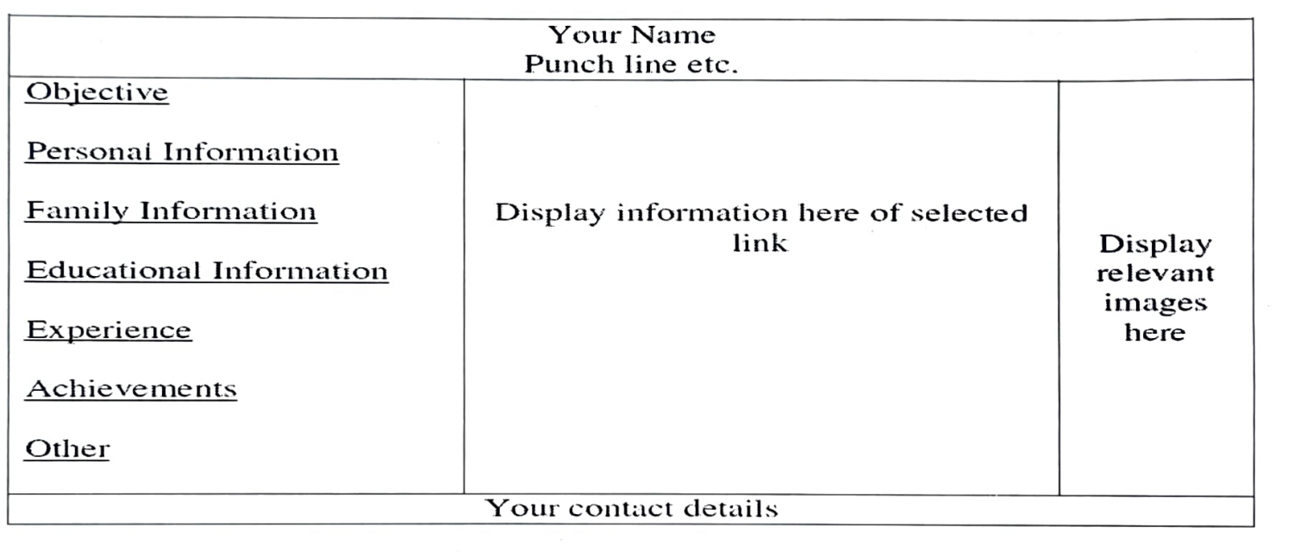

**SOURCE CODE**

**Frame.html**

<!DOCTYPE html>

<html lang="en">

<head>

<meta charset="UTF-8">

<meta http-equiv="X-UA-Compatible" content="IE=edge">

<meta name="viewport" content="width=device-width, initial-scale=1.0">

<title>Frames</title>

<style>

.outer {

display: flex;

flex-direction: column;

justify-content: center;

align-items: center;

margin: 30px 0;

}

.info{

text-align: center;

border: 1px solid;

}

.topHead{

/* width: 100%; */

text-align: center;

border: 1px solid;

}

</style>

</head>

<body>

<div class="outer">

<div class="inner">

<div class="topHead">

<h3>Vipul Kumar</h3>

<p>know more about me</p>

</div>

<iframe style="border: 1px solid black " width="200" height="300" name="first" src="./First.html"

frameborder="0">

</iframe>

<iframe style="border: 1px solid black" width="200" name="second" height="300" src="./second.html"

frameborder="0">

</iframe>

<iframe name="third" style="border: 1px solid black" width="200" height="300" src="./third.html"

frameborder="0"></iframe>

<p class="info">vipulchauhan1123@gmail.com</p>

</div>

</div>

<hr>

<h4 style="text-align: center;">Name : Vipul Kumar, Roll NO : 61 (2018856)</h4>

</body>

</html>

**OUTPUT**

